# CS 255 System Design Document Template

## UML Diagrams

### UML Use Case Diagram

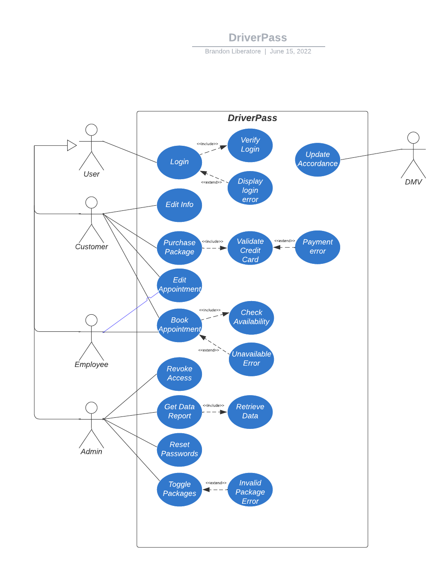

### UML Activity Diagrams

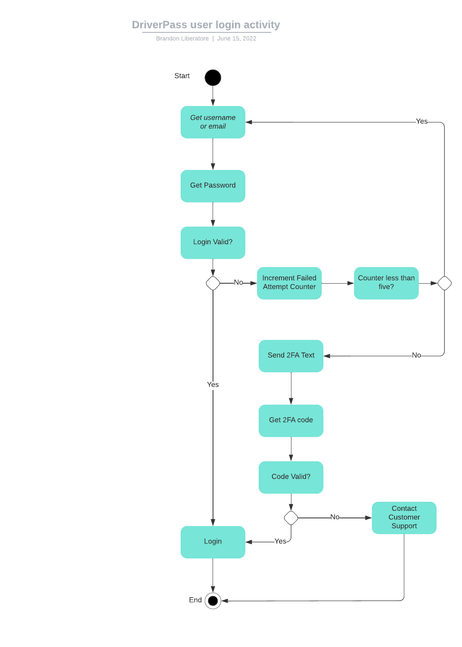

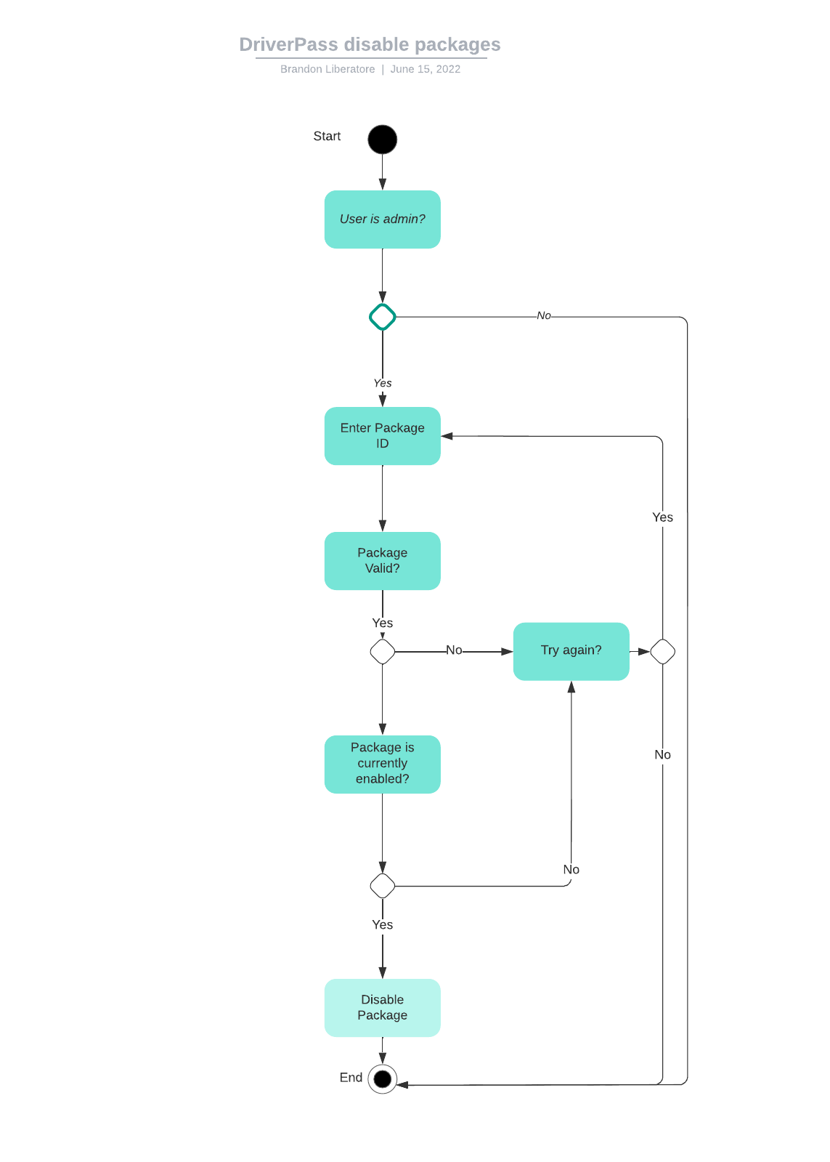

### UML Sequence Diagram

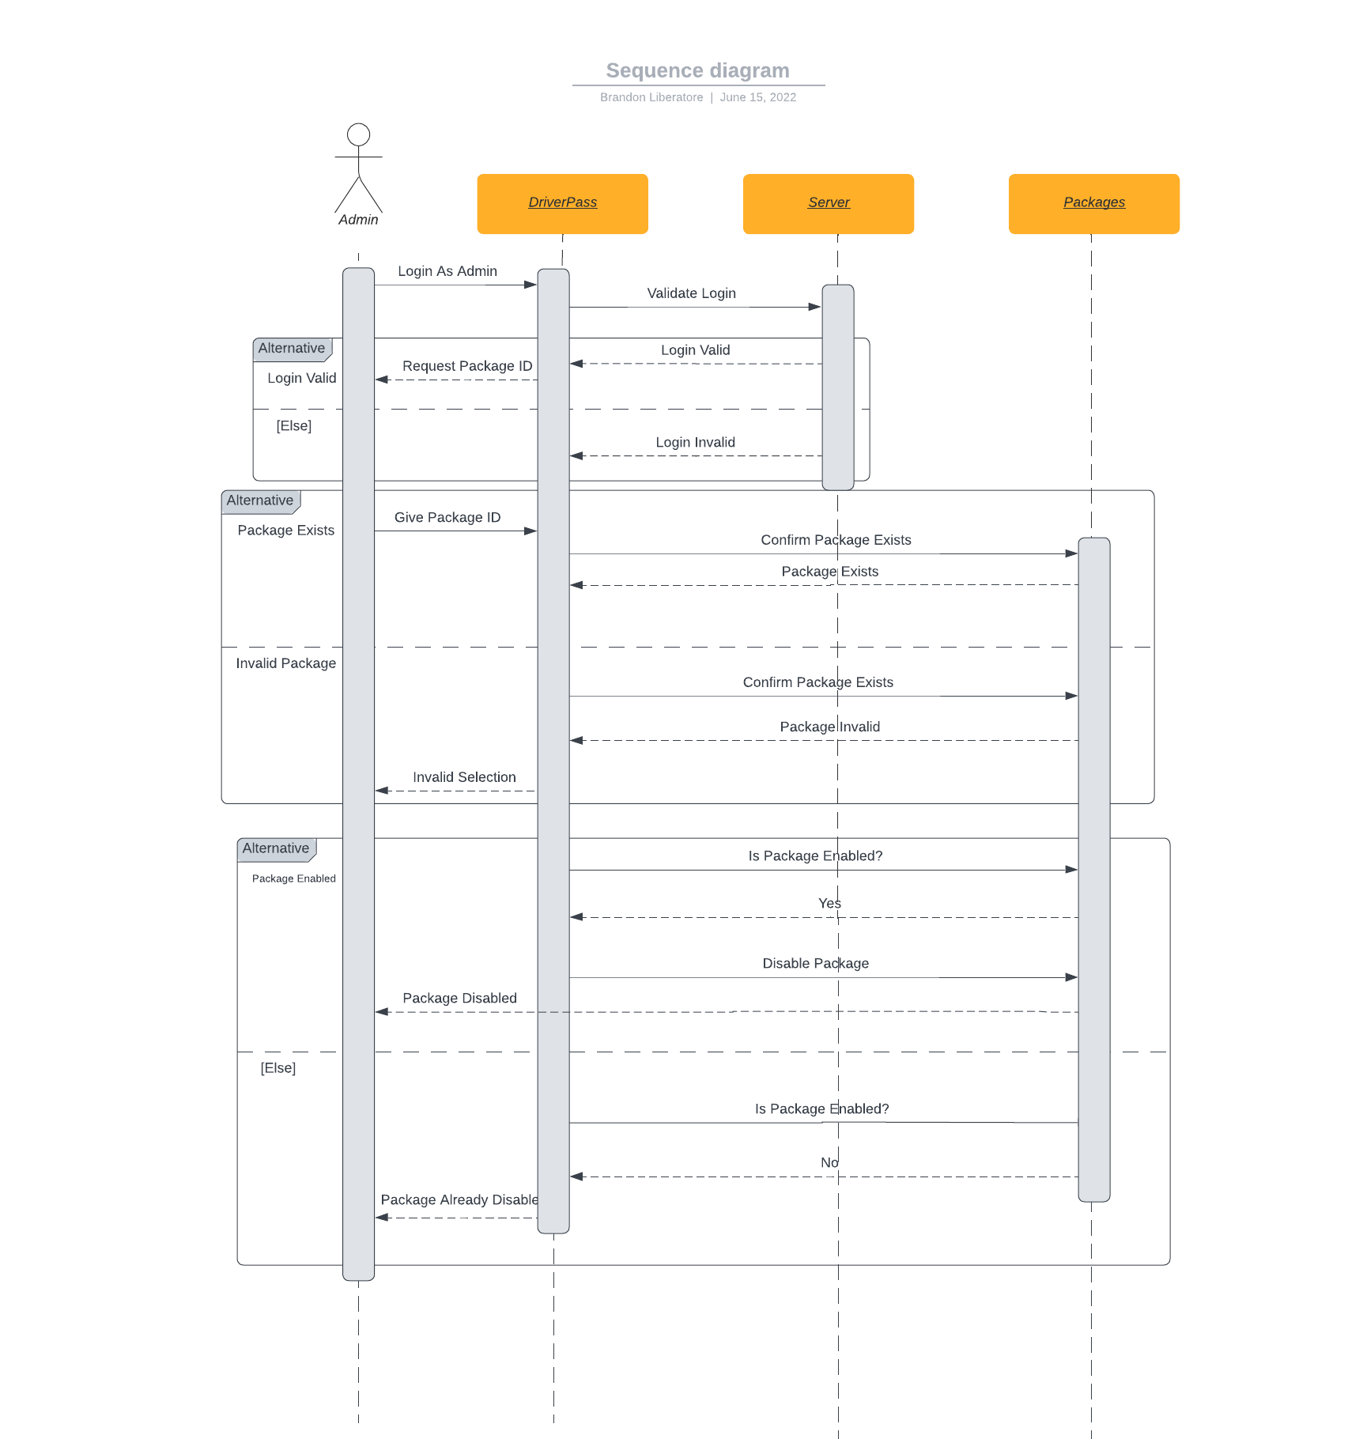

### UML Class Diagram

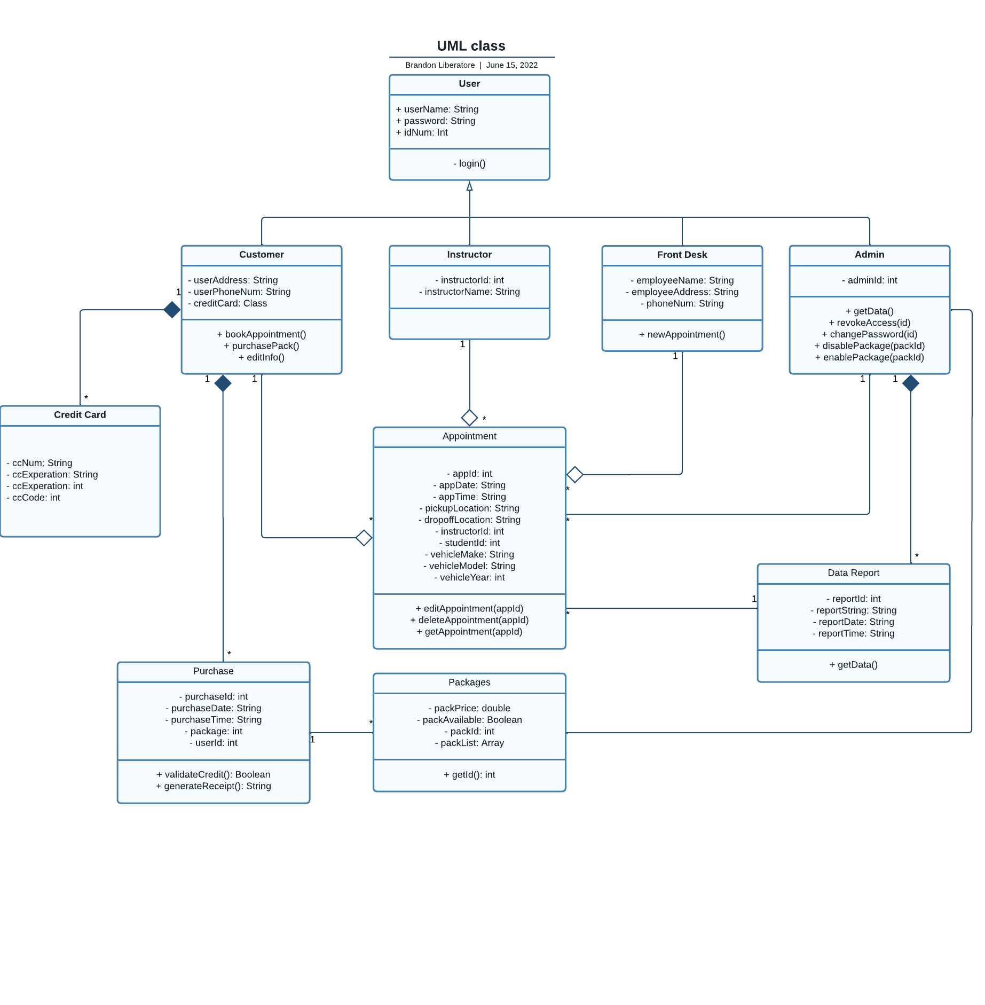

## Technical Requirements

Required hardware for system

* Server (Cloud provided for scalability)
* PC, Mac, or Linux machine for access
* Necessary IO (Mouse, Keyboard)
* Monitor
* Internet Router
* Stable supply of power
* Required cables for connecting hardware

Software Requirements

* Operating System (MacOS, Linux, Windows, Android, iOS)
* Web Browser (Chrome, Edge, Firefox, Safari)

Tool Requirements

* Visual Studio Code, IntelliJ, Eclipse (for building and maintenance)
* Industry standard encryption software

Infrastructure Requirements

* Physical location for DriverPass office
* Vehicles
* High speed internet access
* Electricity with backup options recommended
* Cloud based server